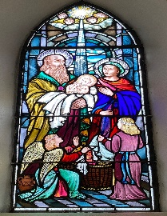
Newsletter Third Sunday Of Easter Year B 14th April 2024
Donore Parish with Duleek Parish
Parishes of the Duleek Deanery
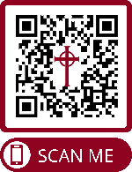
Fr. Mark English Adm.
Fr. Declan Kelly C.C.
Fr. Francis Musoke A.P. Caroline Doyle
Parochial House The Parish Office Duleek C/o Parochial House
Co. Meath Duleek
Tel: 041-9823205 Email:duleekparish@gmail.com www.donorerossnareeparish.com Tuesday – Thursday 10am-5pm

Mass Intentions
Church of the Nativity of our lady, Donore

Sunday 11am Missa pro populo

Tuesday 9am Adoration of the Blessed Sacrament
Wednesday 9am Missa pro populo
Thursday 9am Missa pro populo
Friday 9am Missa pro populo

Sunday 11am Missa pro populo

Church of the Nativity of our lady, Rossnaree
Saturday 6.30pm Philomena Gough.

Saturday 6.30pm Missa pro populo
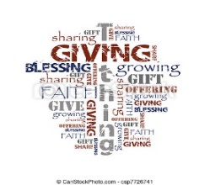
If you have no cash you can just scan your phone over this QR code to contribute to the basket collection.

MASS OFFERTORY COLLECTION (Basket Collection): € 270
PARISH DEVELOPMENT FUND (Weekly Envelopes): € 268
Donore Fund Account:
IBAN IE38 AIBK 9320 9446 7323 44

Society of St. Vincent de Paul
Helpline 1800 677 777 or
Contact 087-0931068

Accord
For Marriage Preparation Courses or for marriage and relationship counselling www.accord.ie

Child Safeguarding
See the church notice boards and diocesan website

Vocations
Ever think about becoming a priest for the Diocese of Meath? Contact Fr. Mark

Rite of Christian Initiation of Adults (R.C.I.A.)
A process for anyone enquiring about becoming a Catholic and for those baptised who never celebrated the Sacraments of Holy Communion or Confirmation. More info on all the above on www.dioseseofmeath.ie

In Baptism we welcome into our Faith Community: Axel Brendan Conlon-McKeown.
Community notices
Lotto: 11, 24, 25, 26 No Jackpot winner
Consolation prizes €25 Irene McDonnell & Patrick McLoone
Next week’s jackpot €4,020

Next weekend is Vocations Sunday and the Offertory Collection is for the education of our seminarians, vocations promotion and support in the diocese of Meath. Your contribution is most appreciated and we seek your continual prayers for those discerning the Lord’s prompting to serve the People of God as a priest in our diocese.

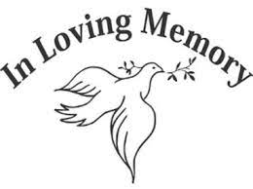
Cemetery Sunday Weekend July 13th/14th 2024
Blessing of the graves will take place on Saturday 13th July at 4pm in Donore old Cemetery, 5pm Leck Cemetery and 6:30pm in Knockcommon Cemetery. On Sunday 14th at 11am in Donore Cemetery. Please note that no individual mass intentions will be taken cemetery Sunday weekend as all masses will be offered for those buried in our cemeteries.

Seeking a Blessing It is custom to have a new house or car blessed; perhaps even the farm in Spring or the office or work place for God’s protection etc. Please don’t hesitate to request such a blessing from Fr. Mark or Fr. Declan. Always feel free to phone or email the Parish Office to make arrangements. Also if permitted by the hospital or nursing residence Fr. Mark and Fr. Declan would gladly visit any parishioner if they or their family so desired. Be assured too that most hospitals and nursing care facilities usually have pastoral care procedures provided for Anointing the sick and bringing Holy Communion, just ask and they will make arrangements for you and your loved ones.
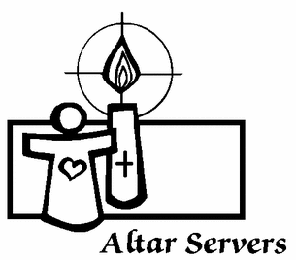
Altar Servers Being an altar server is a brilliant job at Mass! Altar servers lend a hand getting everything ready in the church before Mass time. They help the priest and all the people to celebrate the Mass. Altar servers can also help at funerals and weddings too! Altar servers keep an eye to make sure the bells are rung at the right time, reminding everyone it's a special moment in the Mass. They look after the books, the chalice, the candles and many other things as well. Usually kids can begin altar serving once they have made their first Holy Communion. You can start at any age and keep serving even when at secondary school. So if you'd like to be an altar server discuss with your parents and then please ask any of the priests at Mass!

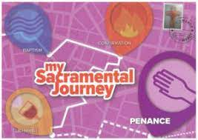
Confirmation & First Holy Communion As families and local faith communities we continue to encourage our parents as they support the children along the journey of preparing for the celebrations of these sacraments in 2024. This weekend the children preparing for First Holy Communion and the recently Confirmed will receive another sticker in their Sacramental Passport for The Easter Season, let us think about the joy of being a young Christian in the world today!
Meath Pilgrimage to Lourdes The Diocesan Pilgrimage to Lourdes will travel on September 10th and will be led by Bishop Deenihan. Fares start from €769 with various hotels available. Further information and booking forms are available from Joe Walsh Tours, 89 Harcourt Street, Dublin. www.joewalshtours.ie Tel.: 01 2410800
Meath Diocesan Pilgrimage to Knock on Sunday 11th August 2024. The Pilgrimage led by Bishop Tom Deenihan, will be accompanied by the Meath Diocesan Choir. The Cause for Fr. Willie Doyle Pilgrimage will also take place this same day. A bus will be going from the parish. More details later. Save the date!
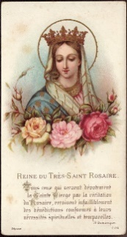
Queen Of The May Let us keep the treasured tradition of honouring our Lady, the Mother of God during the month of May with special devotion. Perhaps get the children in your home to help set up a May altar. Make time for the family rosary, especially with children celebrating their First Holy Communion and those who recently made their Confirmation
The Regina Caeli
℣. Queen of Heaven, rejoice, alleluia
℟. For he whom you were worthy to bear, alleluia.
℣. Has risen as he said, alleluia.
℟. Pray for us to God, alleluia.
℣. Let us pray: O God, who through the resurrection of your Son Jesus Christ gave rejoicing to the world, grant we pray, that through his Mother, the Virgin Mary, we may obtain the joys of everlasting life. Through Christ our Lord. ℟. Amen.
(The Regina Caeli is recited in place of the Angelus during the Easter season, from Easter Sunday until Pentecost.)

